Chapter 2, Solution 45

- 10//40 = 8, 20//30 = 12, 8//12 = 4.8

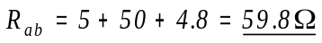

- 12 and 60 ohm resistors are in parallel. Hence, 12//60 = 10 ohm. This 10 ohm
and 20 ohm are in series to give 30 ohm. This is in parallel with 30 ohm to give
30//30 = 15 ohm. And 25//(15+10) = 12.5. Thus,

